COMMANDS

- pwd : pwd Command The pwd command stands for print working directory. It is one of the most basic and frequently used commands in Linux. When invoked the command prints the complete path of the current working directory.

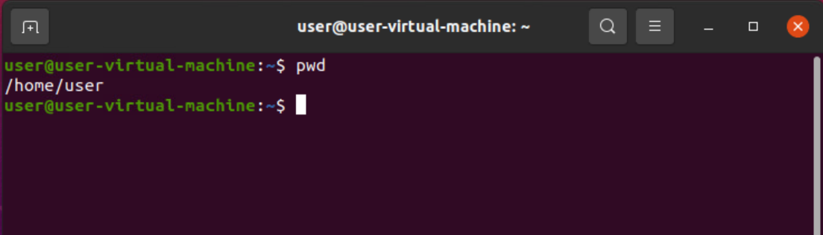
- clear:clear is a standard Unix computer operating system command that is used to clear the terminal screen.
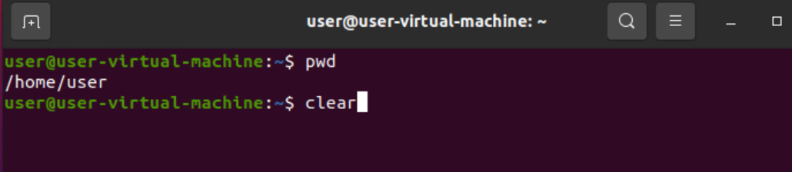
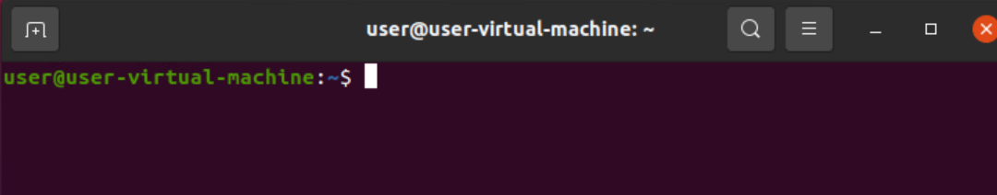
- ls: Listing Directory Contents with ls: You can list the contents of your current working directory with ls. This is the most common usage of ls.
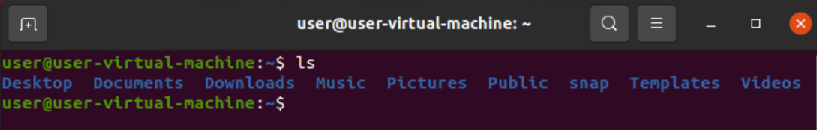
- man:man command in Linux is used to display the user manual of any command that we can run on the terminal. It provides a detailed view of the command which includes NAME, SYNOPSIS, DESCRIPTION, OPTIONS, EXIT STATUS, RETURN VALUES, ERRORS, FILES, VERSIONS, EXAMPLES, AUTHORS and SEE ALSO.

- ls -l: To show long listing information about the file/directory. The ls command will only display the files. But if you want your files to be displayed in a long list format, then you can use ls -l command.
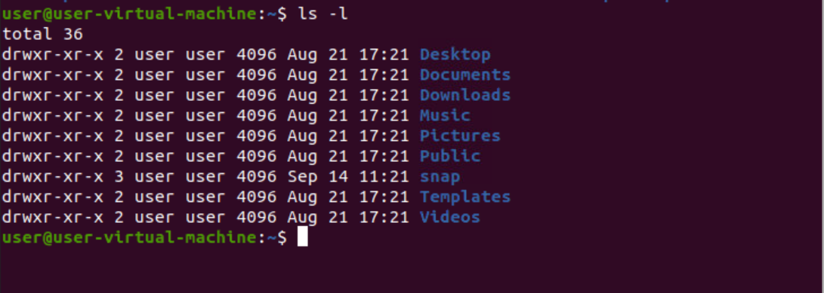
- cd: It will give you the whole list of a directory including the hidden files also. In Linux, hidden files start with a dot (.) and can't be seen in the regular directory.

- ls -f: It will give you the whole list of a directory including the hidden files but without format.
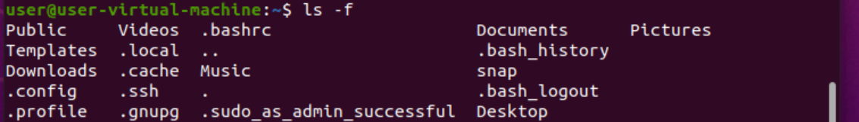
- ls -a: It will give you the whole list of a directory including the hidden files also. In Linux, hidden files start with a dot (.) and can't be seen in the regular directory.
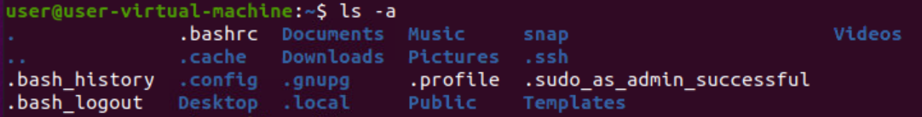
- ls -A: It will give you the whole list of a directory without the hidden files.
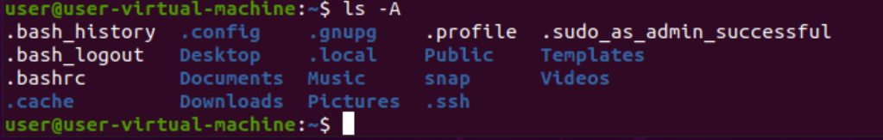
- mkdir: In Linux if you want to create a new directory, you can do so by using the mkdir command. The mkdir command is used to make a directory in Linux.

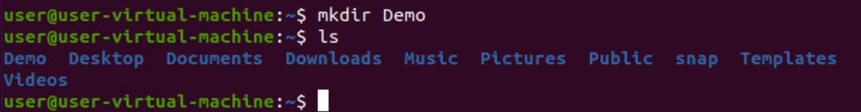
- mv:The mv command is one of the basic Linux commands that is used to move files and directories from one location to another. It is also used to rename files and directories.

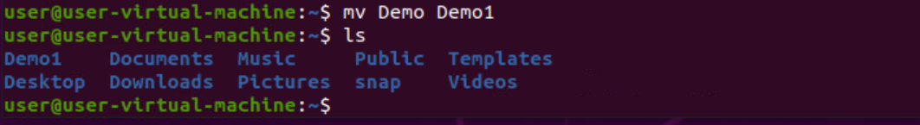

- rmdir: The rmdir command removes empty directories from a filesystem. This document describes the GNU/Linux version of rmdir. Description. The rmdir command removes each directory specified on the command line, if they are empty.
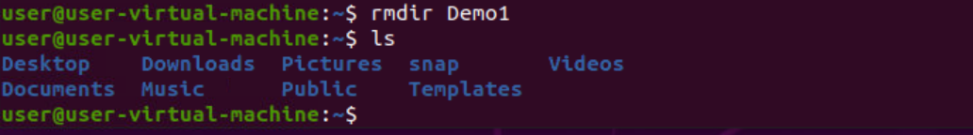
- sudo:The sudo command runs any Linux command as the superuser. It is used to run commands which require special privileges to execute.
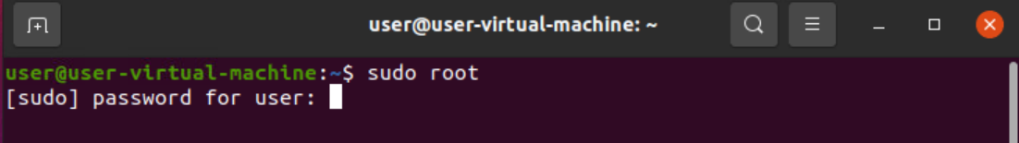

- Cat: The cat command is a filter that can be used for multiple purposes.
- Display the contents of text files.
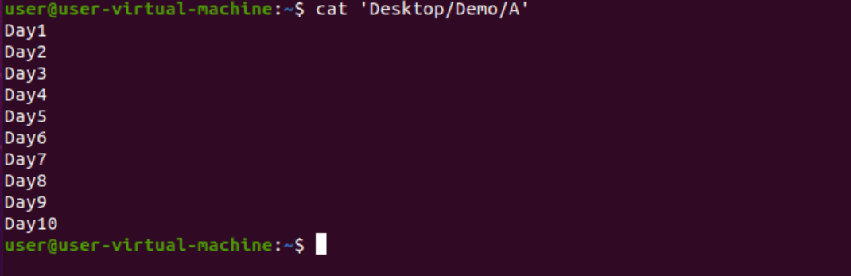

- List the contents of file1 and file2 together.
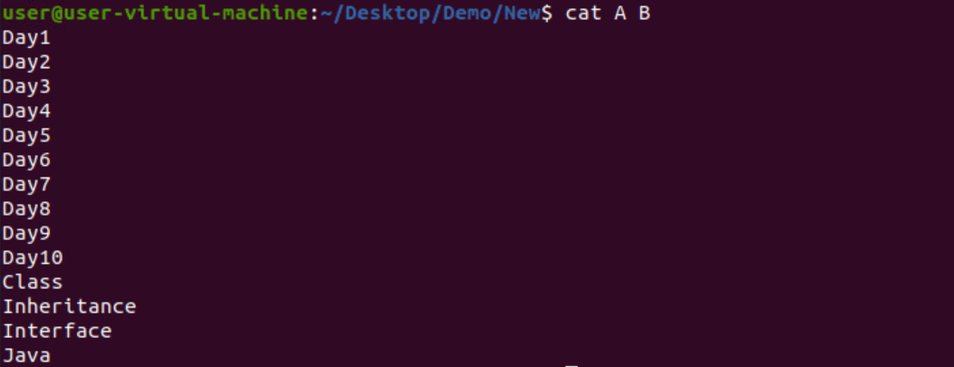

- Copy contents of file1 to file2
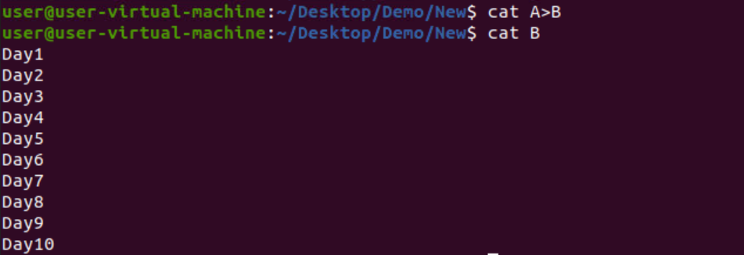
- who: The who command is used to get information about currently logged in user on to system.

- date: Display the current date and time in Linux. To start with, you just need to enter the command “date” to display the date and time.
- touch: The touch command is the easiest way to create new, empty files.
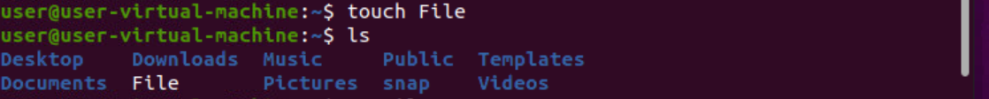

- rm: rm is a command-line utility for removing files and directories. It is one of the essential commands that every Linux user should be familiar with.

- cat -b: It displays the contents of the file with the line number.
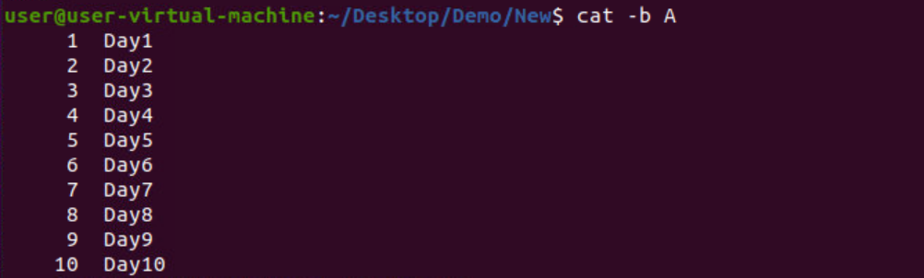
- sort: In computing, sort is a standard command line program of Unix and Unix-like operating systems, that prints the lines of its input or concatenation of all files listed in its argument list in sorted order.
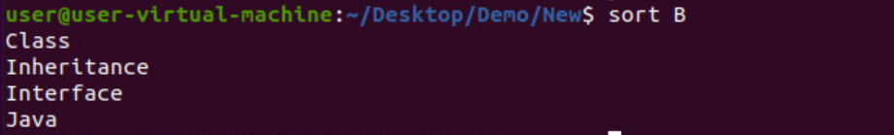
- tac: tac command in Linux is used to concatenate and print files in reverse. This command will write each FILE to standard output, the last line first. When no file is specified then this command will read the standard input.
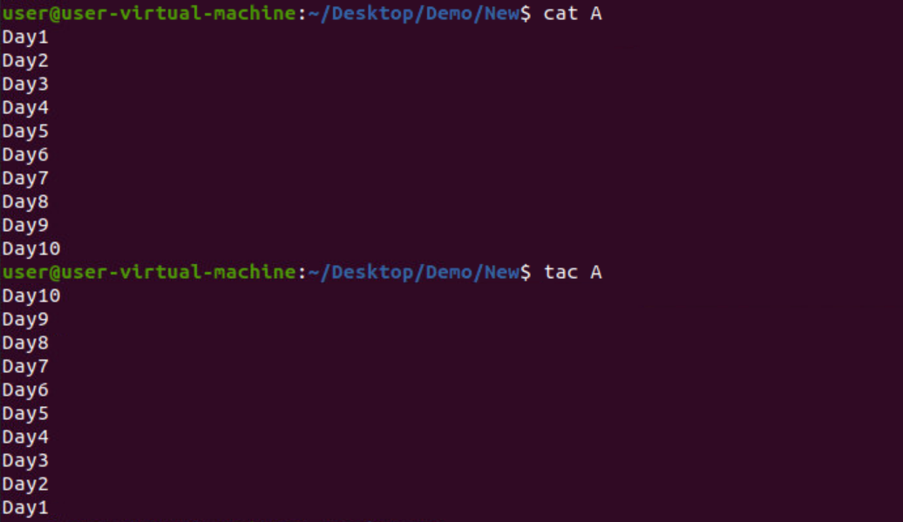

- bc: bc command is used for command line calculator. It is similar to basic calculator by using which we can do basic mathematical calculations.

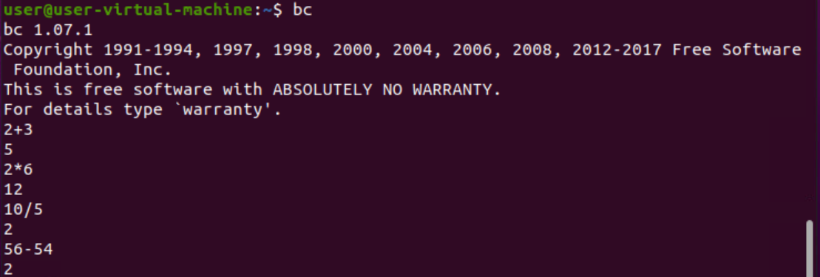
- ls -la: To list all the files in a directory including the hidden files with additional information use ls -la.
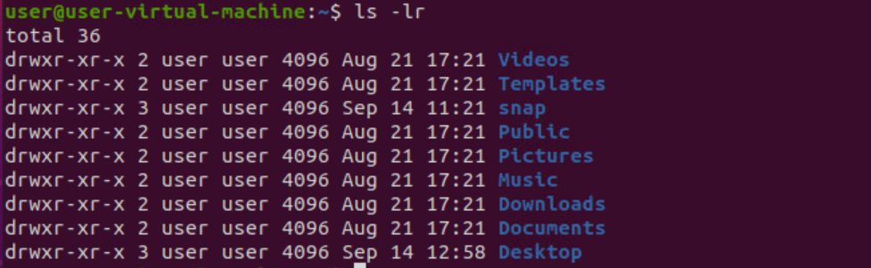
- cp: The cp command has a simple purpose to copy files and folders from one place to another.
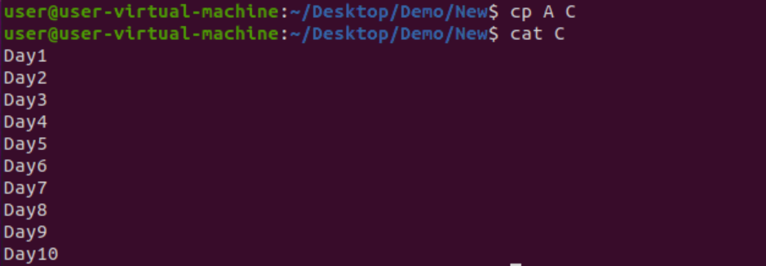

- mkdir -p: With the help of mkdir -p command you can create sub-directories of a directory. It will create parent directory first, if it doesn't exist. But if it already exists, then it will not print an error message and will move further to create sub-directories.

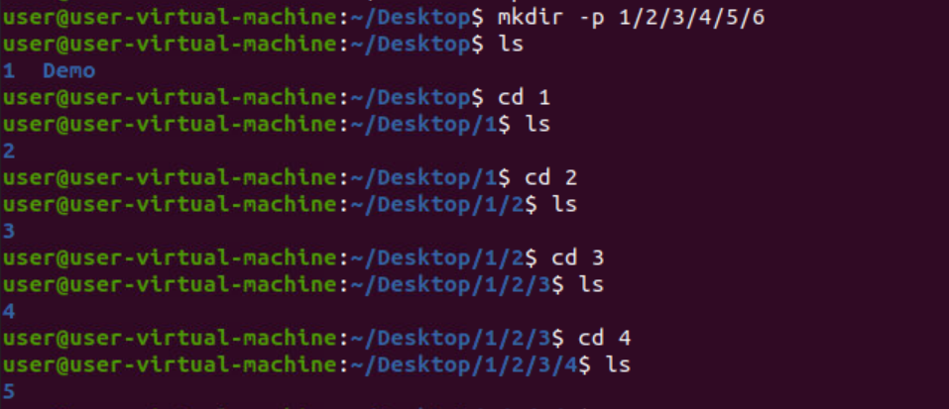
- rm -rf: With the help of mkdir -p command you can delete sub-directories of a directory.

- passwd: passwd command in Linux is used to change the user account passwords. The root user reserves the privilege to change the password for any user on the system, while a normal user can only change the account password for his or her own account.

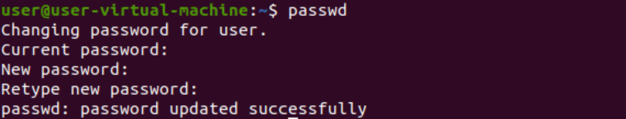

- tree:tree is a recursive directory listing program that produces a depth-indented listing of files. With no arguments, tree lists the files in the current directory.
